Partial derivative

1. Let 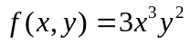. Find
(a) 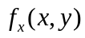 (b) 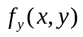 (c) 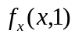 (d) 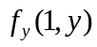
(f) 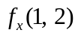 (g) 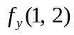.

2. Let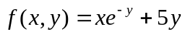, 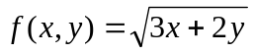
a) Find the Slope of the surface 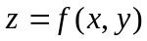 in the x- direction at the corresponding points (3,0), (4,2).
b) Find the slope of the surface in the y direction at the corresponding points (3,0), (4,2).

3. Let
a) Find the Slope of the surface in the x- direction at the point (4,2)
b) Find the slope of the surface in the y direction of the point (4,2)

4. Let 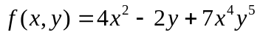 , Find

(a) 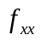, (b) 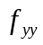, (c) 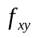 ,(d) 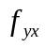.
5. Let 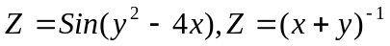
(a)Find the rate of Change of z w. r. to x at the corresponding points (2,1), (-2, 4) with y kept fixed.
(b) Find the rate of Change of z w. r. to y at the corresponding points (2,1), (-2, 4) with x kept fixed.

6. Let 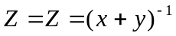
(a) Find the rate of Change of z w. r. to x at the point (-2, 4) with y kept fixed.
(b) Find the rate of Change of z w. r. to y at the point (-2, 4) with x kept fixed

7. Let 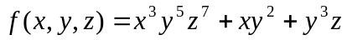 , find
(a) (b) 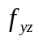 (c) 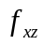 (d) 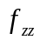 (e) 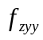 (f) 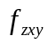 (g) 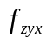 (h) 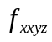.
8. Let 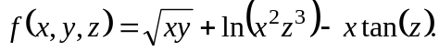 Compute 